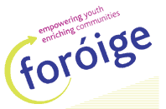
Julianstown
Youth Club

Registration Night for 2015-2016

DATE: Friday 11th September
TIME: 7.30 – 9pm
PLACE: Parish Rooms, Laytown Rd,
Julianstown

Parents and young people are invited to come and register / find out more about the Club

To register:
- Young person must be 12 years of age or over
- Pay annual membership/insurance fee of €20 (no more than €30 per family)
- Have parents fill out and sign membership form

